**03/08/2024 JAVA-CSA0893**

**1]WRITE A JAVA PROGRAM USING HASHSET.**

**Program:**

**import java.util.HashSet;**

**public class HashSetExample{**

**public static void main(String[] args){**

**HashSet<String> set=new HashSet<>();**

**set.add("Apple");**

**set.add("Banana");**

**set.add("Cherry");**

**set.add("Apple");**

**System.out.println("HashSet: "+set);**

**System.out.println("Is Apple in the set? "+set.contains("Apple"));**

**set.remove("Banana");**

**System.out.println("HashSet after removing Banana: "+set);**

**set.clear();**

**System.out.println("HashSet after clearing: "+set);**

**}**

**}**

**Output:**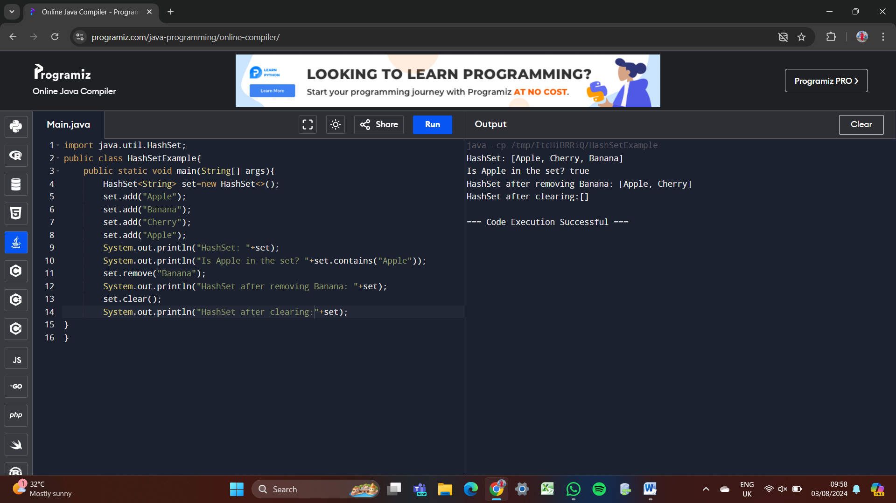

**2] WRITE A JAVA PROGRAM USING LINKEDHASHSET.**

**Program:**

**import java.util.LinkedHashSet;**

**public class LinkedHashSetExample {**

**public static void main(String[] args) {**

**LinkedHashSet<String> set = new LinkedHashSet<>();**

**set.add("Apple");**

**set.add("Banana");**

**set.add("Cherry");**

**set.add("Apple");**

**System.out.println("LinkedHashSet: " + set);**

**System.out.println("Apple: " + set.contains("Apple"));**

**set.remove("Banana");**

**System.out.println("after removing Banana: "+set);**

**set.clear();**

**System.out.println("after clearing: "+set);**

**}**

**}**

**Output:**

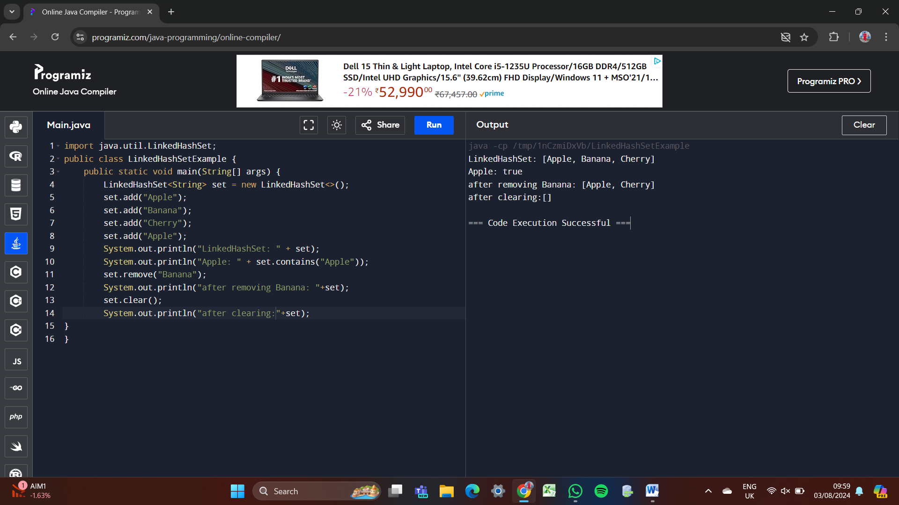

**3] WRITE A JAVA PROGRAM USING TREESET.**

**Program:**

**import java.util.TreeSet;**

**public class TreeSetExample{**

**public static void main(String[] args){**

**TreeSet<String> set2=new TreeSet<>();**

**set2.add("One");**

**set2.add("Two");**

**set2.add("Three");**

**set2.add("Four");**

**set2.add("Five");**

**System.out.println("TreeSet2: "+set2);**

**System.out.println("Is TreeSet2 empty: " + set2.isEmpty());**

**System.out.println("Size of TreeSet2: " + set2.size());**

**set2.clear();**

**System.out.println("after clearing: "+set2);**

**}**

**}**

**Output:**

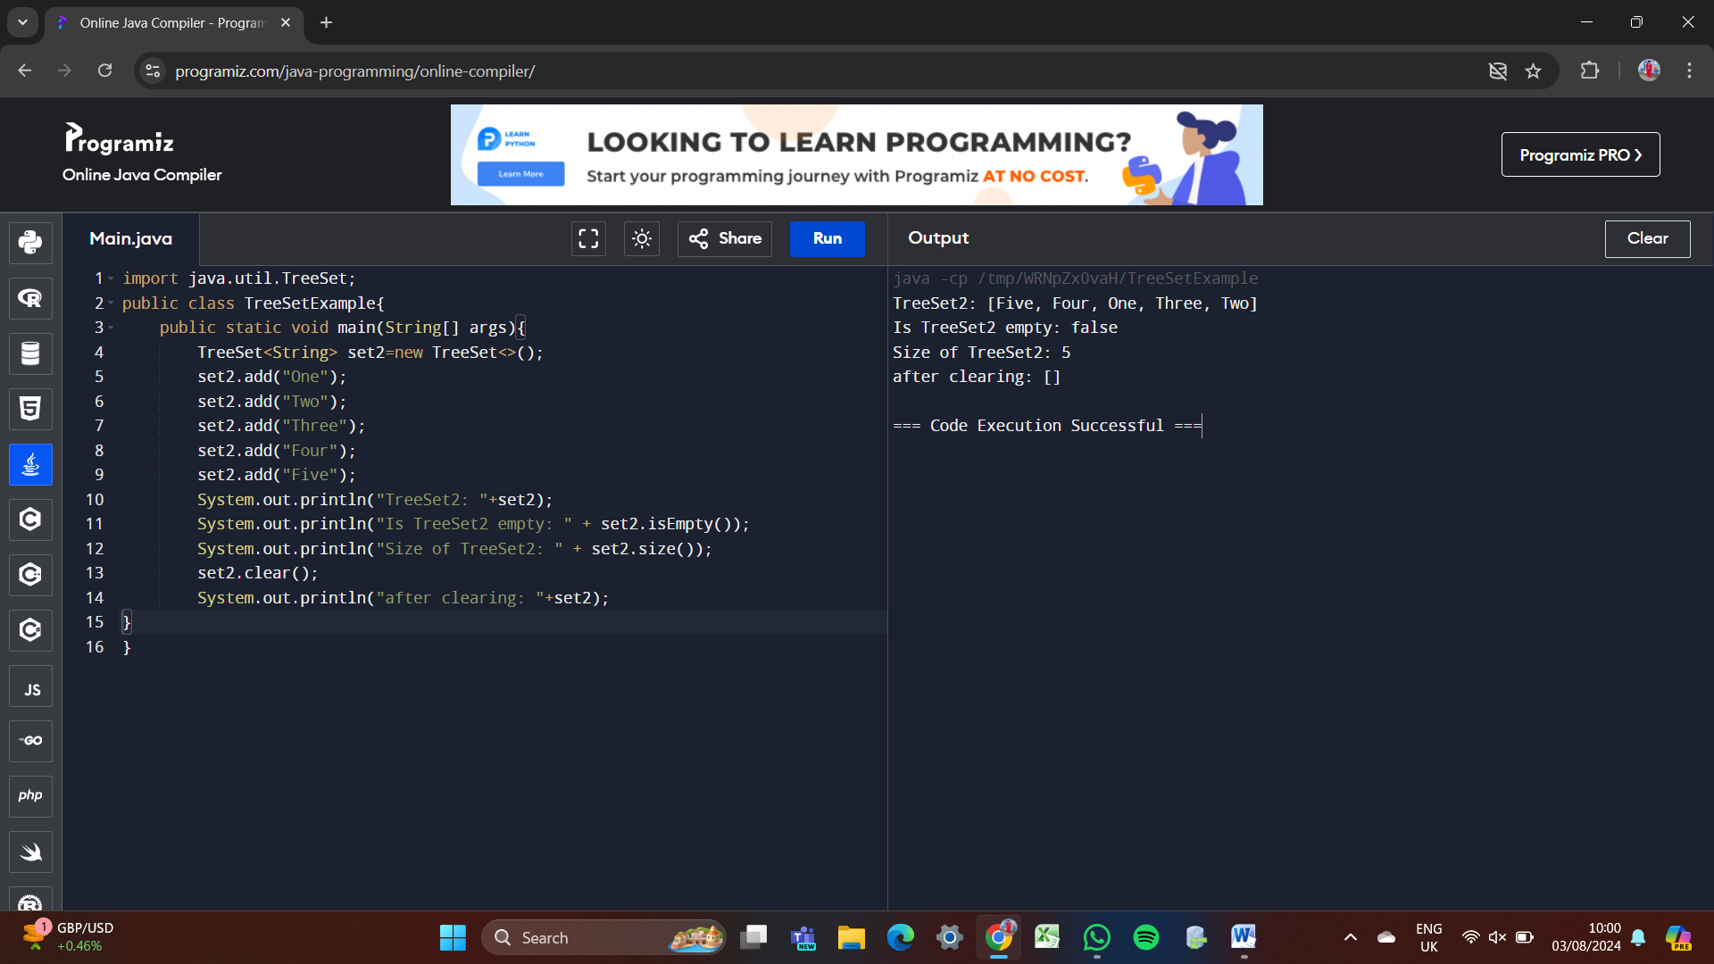

**4] WRITE A JAVA PROGRAM USING LINKED LIST.**

**Program:**

**import java.util.LinkedList;**

**import java.util.List;**

**public class LinkedListExample {**

**public static void main(String[] args) {**

**List<String> linkedList = new LinkedList<>();**

**linkedList.add("Apple");**

**linkedList.add("Banana");**

**linkedList.add("Cherry");**

**System.out.println(linkedList);**

**linkedList.remove("Banana");**

**System.out.println(linkedList);**

**}**

**}**

**Output:**

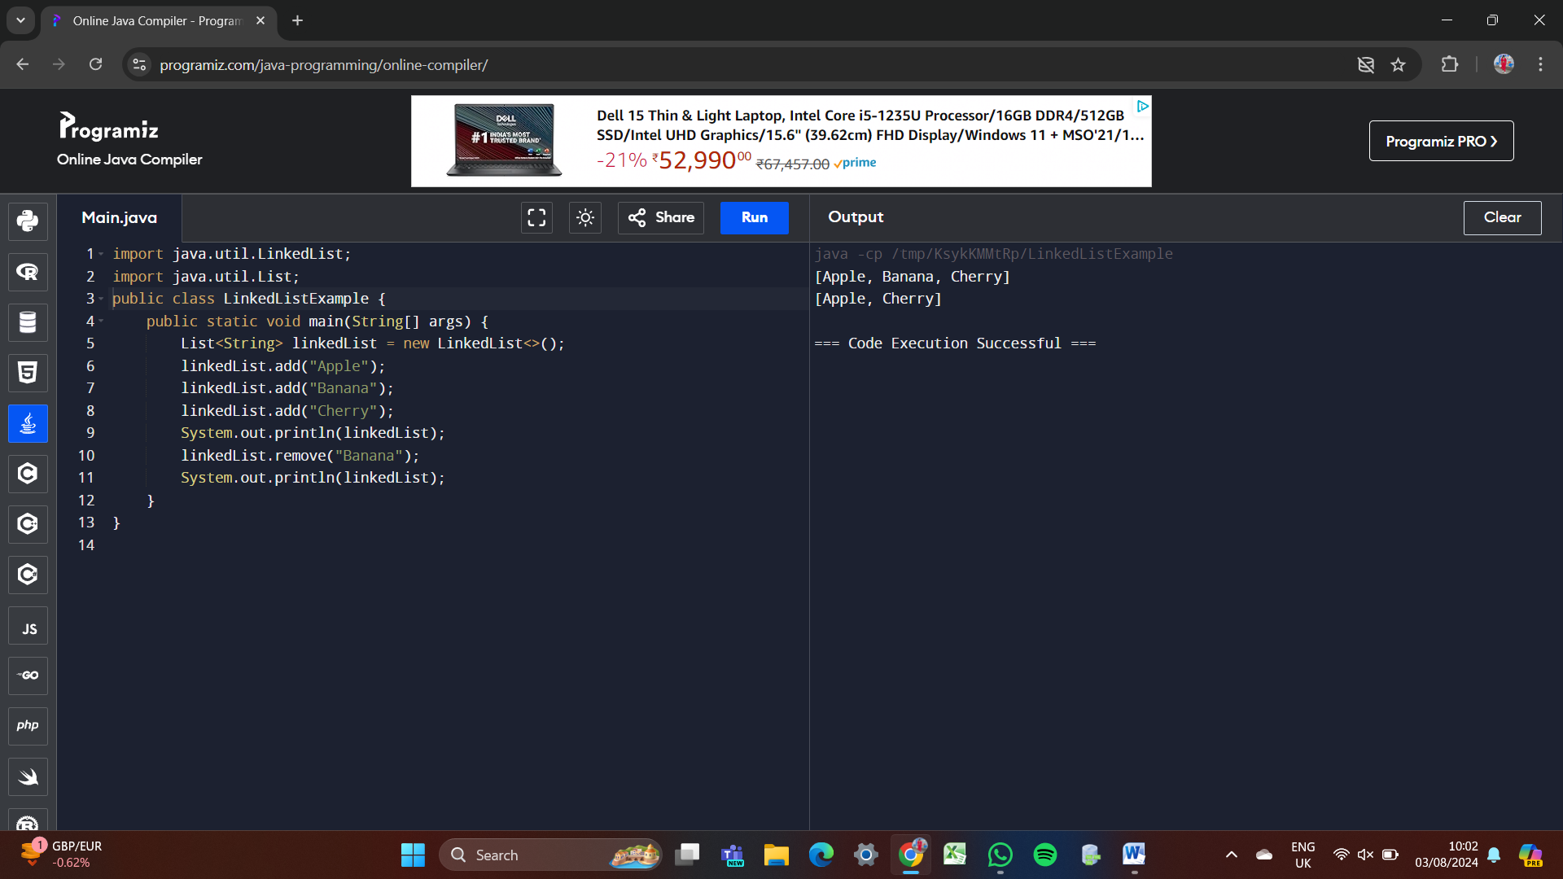

**5] WRITE A JAVA PROGRAM USING STACK.**

**Program:**

**import java.util.Stack;**

**public class StackExample {**

**public static void main(String[] args) {**

**Stack<String> stack = new Stack<>();**

**stack.push("A");**

**stack.push("B");**

**stack.push("C");**

**System.out.println(stack);**

**String poppedElement = stack.pop();**

**System.out.println(poppedElement);**

**System.out.println(stack);**

**}**

**}**

**Output:**

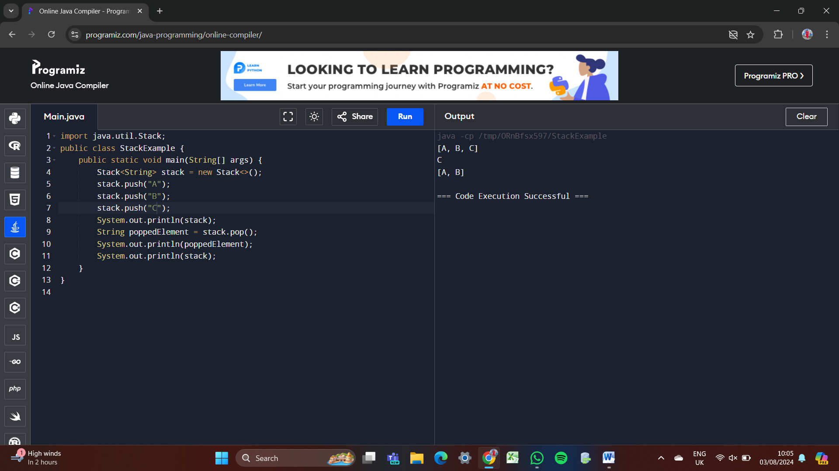

**6] WRITE A JAVA PROGRAM USING VECTOR.**

**Program:**

**import java.util.Vector;**

**public class VectorExample {**

**public static void main(String[] args) {**

**Vector<String> vector = new Vector<>();**

**vector.addElement("A1");**

**vector.addElement("B2");**

**vector.addElement("C3");**

**System.out.println(vector);**

**vector.removeElement("B2");**

**System.out.println(vector);**

**}**

**}**

**Output:**

